**Topics: Descriptive Statistics and Probability**

1. Look at the data given below. Plot the data, find the outliers and find out $μ, σ, σ^{2}$

|  |  |
| --- | --- |
| **Name of company** | **Measure X** |
| Allied Signal | 24.23% |
| Bankers Trust | 25.53% |
| General Mills | 25.41% |
| ITT Industries | 24.14% |
| J.P.Morgan & Co. | 29.62% |
| Lehman Brothers | 28.25% |
| Marriott | 25.81% |
| MCI | 24.39% |
| Merrill Lynch | 40.26% |
| Microsoft | 32.95% |
| Morgan Stanley | 91.36% |
| Sun Microsystems | 25.99% |
| Travelers | 39.42% |
| US Airways | 26.71% |
| Warner-Lambert | 35.00% |

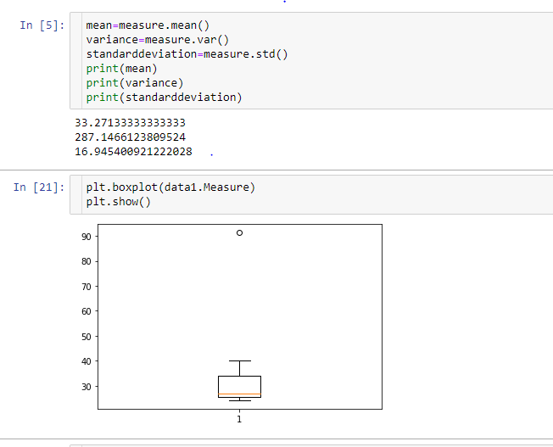

**Sol) by observing the data and with the help of boxplot we can conclude that data have only one outlier(**Morgan Stanley , 91.36%)



Answer the following three questions based on the box-plot above.

1. What is inter-quartile range of this dataset? (please approximate the numbers) In one line, explain what this value implies.

**Sol) inter-quartile range=Q3-Q1**

**=12-5**

**=7**

**it**

1. What can we say about the skewness of this dataset?

**Sol) it is a positive skew ness as the most of the data is concentrated on the right hand side.**

1. If it was found that the data point with the value 25 is actually 2.5, how would the new box-plot be affected?

**Sol) there will be no outlier and the median and mean will going to change of the data .**



Answer the following three questions based on the histogram above.

1. Where would the mode of this dataset lie?

**Sol) the mode of the data lies in the range of 4-8**

1. Comment on the skewness of the dataset

**Sol) the skewness of the data is positive skew .the mean of the data is greater than the median**

1. Suppose that the above histogram and the box-plot in question 2 are plotted for the same dataset. Explain how these graphs complement each other in providing information about any dataset.

**Sol) both the graphs gives about the distribution of the data and also used to find out the outliers of the data set.In histogram the distribution of the particular value can be founding is easy where in case of the boxplot is difficult.**

1. AT&T was running commercials in 1990 aimed at luring back customers who had switched to one of the other long-distance phone service providers. One such commercial shows a businessman trying to reach Phoenix and mistakenly getting Fiji, where a half-naked native on a beach responds incomprehensibly in Polynesian. When asked about this advertisement, AT&T admitted that the portrayed incident did not actually take place but added that this was an enactment of something that “could happen.” Suppose that one in 200 long-distance telephone calls is misdirected. What is the probability that at least one in five attempted telephone calls reaches the wrong number? (Assume independence of attempts.)

**Sol) the probability of call gets mis directed =1/200**

**The probability of calls not get miss directed =199/200**

**The pobability** that at least one in five attempted telephone calls reaches the wrong number=1-(199/200)5

=1-0.975

**=0.0275**

1. Returns on a certain business venture, to the nearest $1,000, are known to follow the following probability distribution

|  |  |
| --- | --- |
| x | P(x) |
| -2,000 | 0.1 |
| -1,000 | 0.1 |
| 0 | 0.2 |
| 1000 | 0.2 |
| 2000 | 0.3 |
| 3000 | 0.1 |

1. What is the most likely monetary outcome of the business venture?

**Sol) the most likely monetary outcome of the buisness venture is profit with a range of 1000 to 2000**

1. Is the venture likely to be successful? Explain

**Sol) yes because the probability of getting the profit is more than the loss .**

1. What is the long-term average earning of business ventures of this kind? Explain

**Sol) the long term average earning of buisness venture of this kind is 1330**

1. What is the good measure of the risk involved in a venture of this kind? Compute this measure

**Sol)the risk involed in the system can be determined by calculating the standard deviation of the data .**